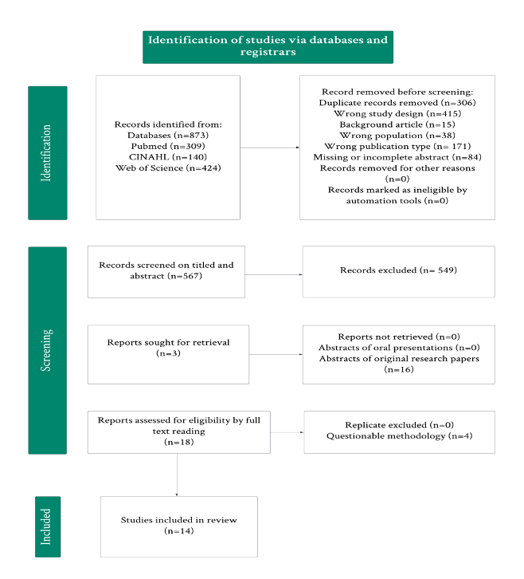
Figure 1. PRISMA Flowchart

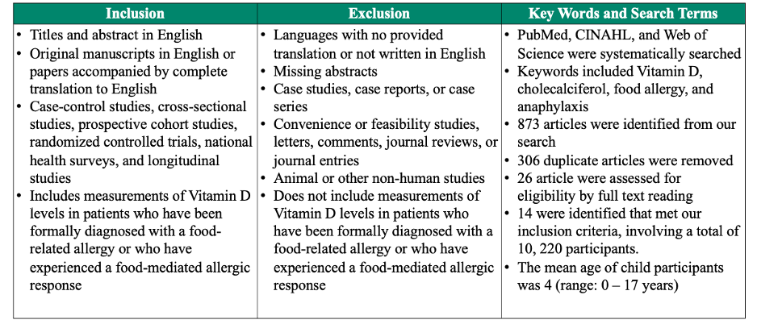

Table 1. Eligibility Criteria and Search Terms
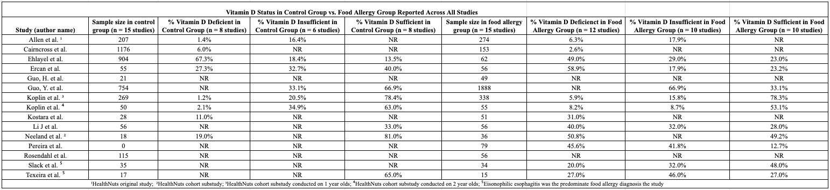

Table 2: Vitamin D Status Across all Studies

NR = Not Reported

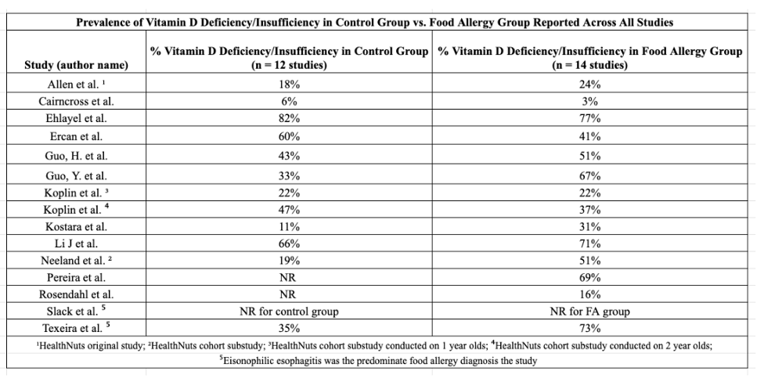

Table 3. Prevalence (%) of Vitamin D Status Among Children and Adults in Included Studies

Supplemental Data

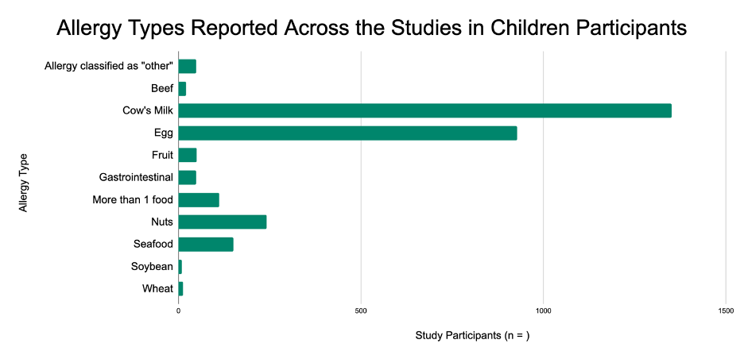
Figure 3. Types of Allergies Identified in the Included Studies

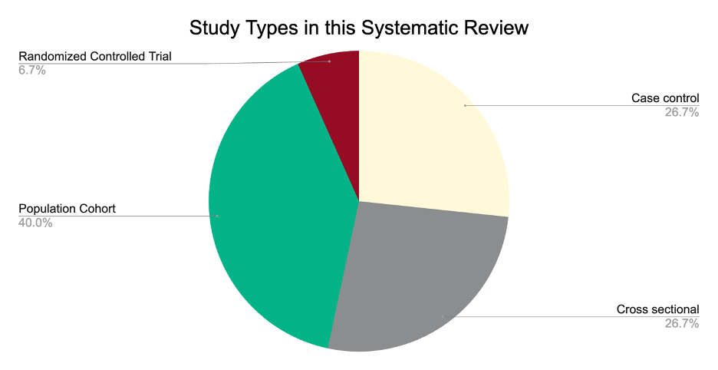

Figure 4. Study Designs Represented in the Included Literature

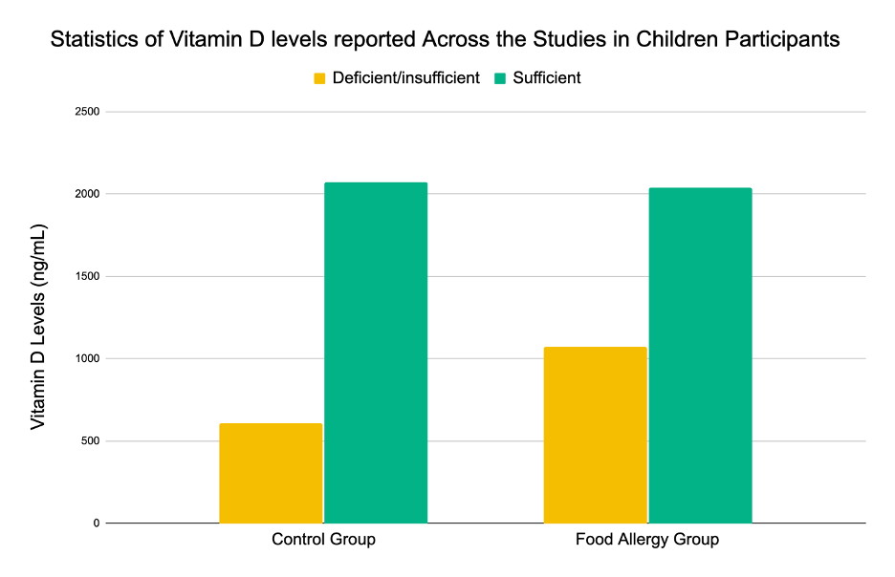
Figure 5. Comparison of Optimal Versus Suboptimal Vitamin D Levels Among Children in Included Studies

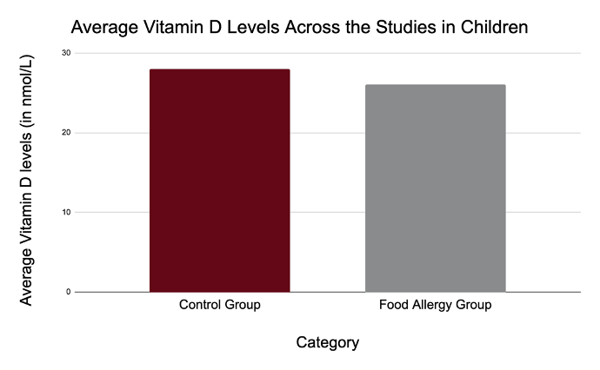
Figure 6. Comparison of Mean Serum Vitamin D Levels Among Children in Included Studies

